LAB PROGRAM 6 ORDER PROCESSING

create database order_processing;

/* CUSTOMER Table */

create table customer(

cust_id int,

cnmae varchar(30),

city varchar(40),

primary key(cust_id));

desc customer;

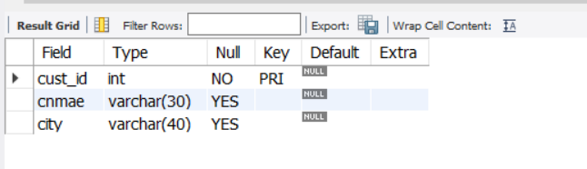

/* ORDERS Table */

create table orders(

order_no int,

odate date,

cust_id int,

ord_amt int,

primary key(order_no),

foreign key(cust_id)references customer (cust_id));

desc orders;

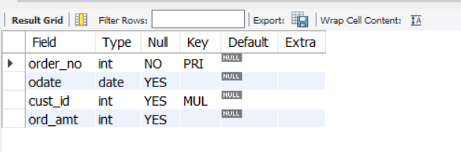

/* ITEM Table */

create table item(

item_id int,

price int,

primary key(item_id));

desc item;

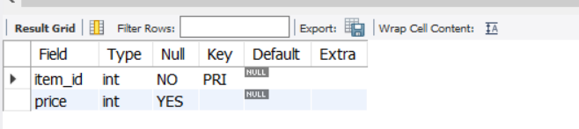

/* ORDER_ITEM Table */

create table order_item(

order_no int,

item_id int,

qty int,

foreign key(order_no)references orders (order_no),

foreign key(item_id)references item(item_id)on delete set NULL);

desc order_item;

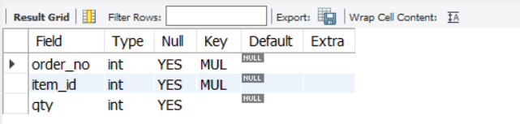

/* WAREHOUSE Table */

create table warehouse(

warehouse_id int,

city varchar(40),

primary key(warehouse_id));

desc warehouse;

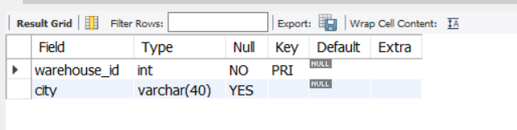

/* SHIPMENT Table */

create table shipment(

order_no int,

warehouse_id int,

ship_date date,

foreign key(order_no)references orders(order_no),

foreign key(warehouse_id)references warehouse(warehouse_id));

desc shipment;

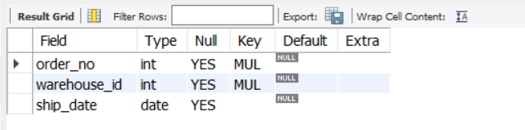

/* Inserts Values To The CUSTOMER Table */

INSERT INTO customer (cust_id, cnmae, city) VALUES (101, 'Asim', 'Gulbarga');

INSERT INTO customer (cust_id, cnmae, city) VALUES (102, 'Amir', 'Delhi');

INSERT INTO customer (cust_id, cnmae, city) VALUES (103, 'Mohsin', 'Mumbai');

INSERT INTO customer (cust_id, cnmae, city) VALUES (104, 'Yaseen', 'Bangalore');

INSERT INTO customer (cust_id, cnmae, city) VALUES (105, 'Aejaz', 'Chennai');

select * from customer;

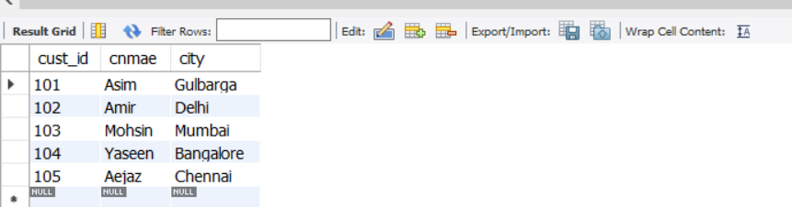

/* Inserts Values To The ORDERS Table */

INSERT INTO orders (order_no, odate, cust_id, ord_amt) VALUES ('201', '2020-03-08', '101', '5000');

INSERT INTO orders (order_no, odate, cust_id, ord_amt) VALUES ('202', '2020-03-20', '102', '1250');

INSERT INTO orders (order_no, odate, cust_id, ord_amt) VALUES ('203', '2020-04-12', '103', '1549');

INSERT INTO orders (order_no, odate, cust_id, ord_amt) VALUES ('204', '2020-03-06', '104', '2500');

INSERT INTO orders (order_no, odate, cust_id, ord_amt) VALUES ('205', '2020-04-04', '105', '4000');

select * from orders;

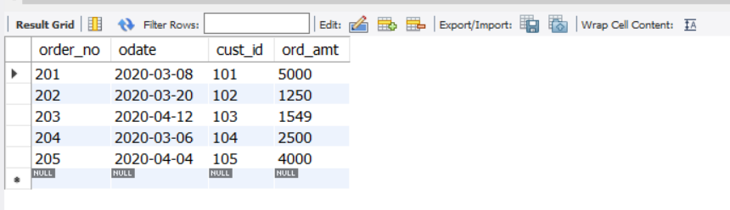

/* Inserts Values To The ITEM Table */

INSERT INTO item (item_id, price) VALUES ('301', '2500');

INSERT INTO item (item_id, price) VALUES ('302', '1250');

INSERT INTO item (item_id, price) VALUES ('303', '5200');

INSERT INTO item (item_id, price) VALUES ('304', '8751');

INSERT INTO item (item_id, price) VALUES ('305', '4512');

select * from item;

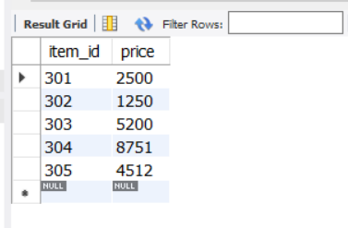

/* Inserts Values To The ORDER_ITEM Table */

INSERT INTO order_item (order_no, item_id, qty) VALUES ('201', '301', '2');

INSERT INTO order_item (order_no, item_id, qty) VALUES ('202', '302', '1');

INSERT INTO order_item (order_no, item_id, qty) VALUES ('203', '303', '3');

INSERT INTO order_item (order_no, item_id, qty) VALUES ('204', '304', '2');

INSERT INTO order_item (order_no, item_id, qty) VALUES ('205', '305', '1');

select * from order_item;

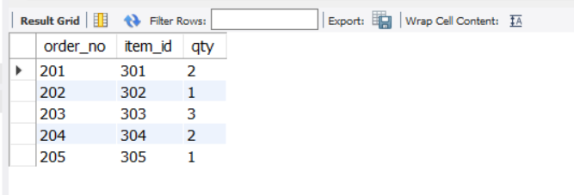

/* Inserts Values To The WAREHOUSE Table */

INSERT INTO warehouse (warehouse_id, city) VALUES ('501', 'Bangalore');

INSERT INTO warehouse (warehouse_id, city) VALUES ('502', 'Gulbarga');

INSERT INTO warehouse (warehouse_id, city) VALUES ('503', 'Mumbai');

INSERT INTO warehouse (warehouse_id, city) VALUES ('504', 'Delhi');

INSERT INTO warehouse (warehouse_id, city) VALUES ('505', 'Chennai');

select * from warehouse;

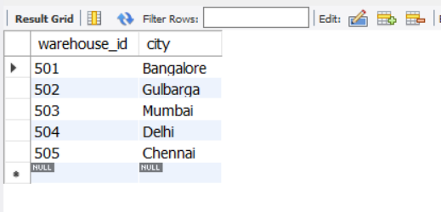

/* Inserts Values To The SHIPMENT Table */

INSERT INTO shipment (order_no, warehouse_id, ship_date) VALUES ('201', '501', '2020-03-10');

INSERT INTO shipment (order_no, warehouse_id, ship_date) VALUES ('202', '502', '2020-04-08');

INSERT INTO shipment (order_no, warehouse_id, ship_date) VALUES ('203', '503', '2020-03-24');

INSERT INTO shipment (order_no, warehouse_id, ship_date) VALUES ('204', '504', '2020-04-25');

INSERT INTO shipment (order_no, warehouse_id, ship_date) VALUES ('205', '505', '2020-02-26');

select * from shipment;

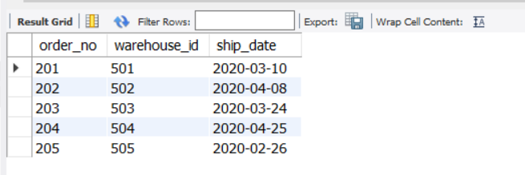

/******************************* QUERIES *******************************/

/* 01. Produce a listing: CUSTNAME, #oforders, AVG_ORDER_AMT, where the middle column is the total numbers of orders by the customer and the last column is the average order amount for that customer. */

select C.cnmae,count(order_no) as No_Of_Orders,avg(ord_amt) as Avg_Amount

from customer C,orders O

where C.cust_id = O.cust_id

group by C.cnmae;

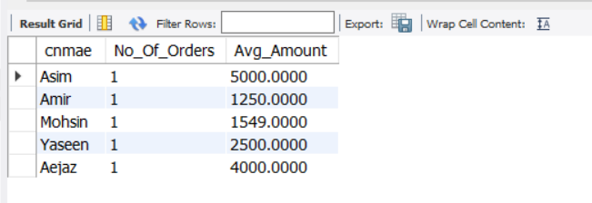

/* 02. List the order# for orders that were shipped from all warehouses that the company has in a specific city. */

select order_no from orders where order_no in

(select order_no from shipment

where warehouse_id in

(select warehouse_id from warehouse

where city = 'Bangalore'));

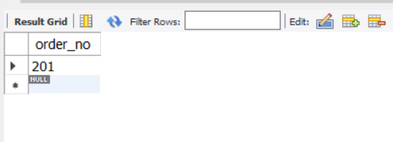

/* 03. Demonstrate how you delete item# 10 from the ITEM table and make that field null in the ORDER_ITEM table. */

select * from item;

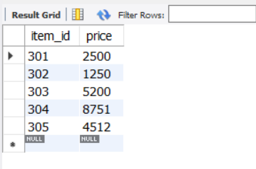

delete from item where item_id = 301;

select * from item;

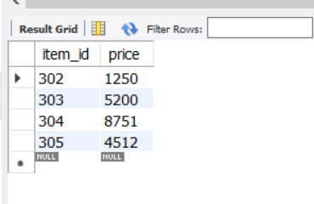

select * from order_item;

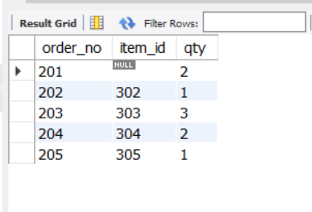

commit;